Assignment no.6
Queue
Course Name : Data Structures-I
Course Code : CS2301
Div : SEDA-B
Student Name : Yashraj Dinesh Hande
Roll Number : 18
Date of Submission : 24/11/2025

Queue
A Queue is a linear data structure that follows the FIFO (First In, First Out) principle — the element inserted first is the one to be removed first.
It is similar to a real-world queue where the first person in line is served first.

🔹 Basic Operations
- Enqueue: Add an element at the rear (end) of the queue.
- Dequeue: Remove an element from the front of the queue.
- Peek / Front: Display the front element without removing it.
- isEmpty: Check if the queue is empty.
- isFull: (For array implementation) Check if the queue is full.

🔹 Types of Queues
- Simple Queue: Normal FIFO queue.
- Circular Queue: Last position connects back to the first, avoiding wasted space.
- Double-Ended Queue (Deque): Insertion and deletion can be done from both ends.
- Priority Queue: Elements are served based on priority rather than order.

🔹 Applications of Queue
- CPU Scheduling and Disk Scheduling.
- Print Spooling and Job Queues.
- Data Buffers in networking (packet management).
- Breadth-First Search (BFS) in graphs and trees.
- Order Processing Systems in real-world scenarios.

Problem 1 : Write a program to keep track of patients as they checked into a medical clinic, assigning patients to doctors on a first-come, first-served basis.
CODE:
#include <iostream>
#include <queue>
using namespace std;

struct Patient {
string name;
int id;
};

int main() {
queue<Patient> q;
int choice, idCounter = 1;

while (true) {
cout << "\n--- Medical Clinic Queue System ---\n";
cout << "1. Check-in Patient\n";
cout << "2. Assign Patient to Doctor\n";
cout << "3. Display Waiting Patients\n";
cout << "4. Exit\n";
cout << "Enter choice: ";
cin >> choice;

if (choice == 1) {
// Patient check-in
Patient p;
cout << "Enter patient name: ";
cin >> p.name;
p.id = idCounter++;
q.push(p);
cout << "Patient " << p.name << " (ID: " << p.id << ") checked in.\n";
}
else if (choice == 2) {
// Assign patient to doctor
if (q.empty()) {
cout << "No patients waiting.\n";
} else {
Patient p = q.front();
q.pop();
cout << "Assigning patient " << p.name
<< " (ID: " << p.id << ") to doctor.\n";
}
}
else if (choice == 3) {
// Display all waiting patients
if (q.empty()) {
cout << "No patients in the queue.\n";
} else {
queue<Patient> temp = q; // copy queue for display
cout << "Patients in queue:\n";
while (!temp.empty()) {
Patient p = temp.front();
temp.pop();
cout << p.id << " - " << p.name << endl;
}
}
}
else if (choice == 4) {
cout << "Exiting...\n";
break;
}
else {
cout << "Invalid choice.\n";
}
}

return 0;
}

Output :
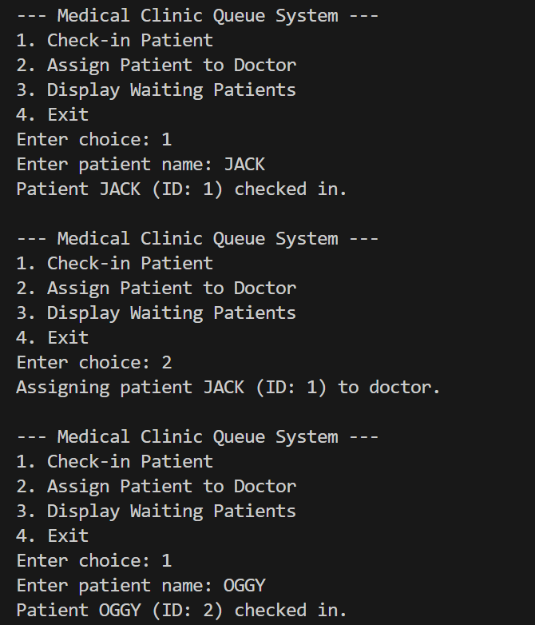

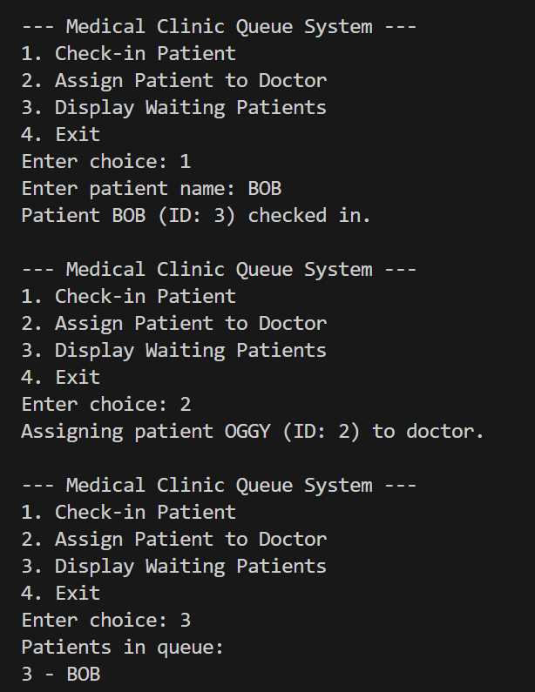

Problem 2 : Pizza parlour accepting maximum n orders. Orders are served on an FCFS basis. Order once placed can’t be cancelled. Write C++ program to simulate the system using circular QUEUE.
CODE:
#include <iostream>
using namespace std;

#define MAX 5 // maximum number of orders allowed

class CircularQueue {
int arr[MAX];
int front, rear;

public:
CircularQueue() {
front = rear = -1;
}

// Check if queue is full
bool isFull() {
return (front == 0 && rear == MAX - 1) || (front == rear + 1);
}

// Check if queue is empty
bool isEmpty() {
return (front == -1);
}

// Place order (enqueue)
void placeOrder(int orderID) {
if (isFull()) {
cout << "Cannot place order " << orderID << ". Pizza Parlour is FULL.\n";
return;
}
if (front == -1) {
front = rear = 0;
} else {
rear = (rear + 1) % MAX;
}
arr[rear] = orderID;
cout << "Order " << orderID << " placed successfully.\n";
}

// Serve order (dequeue)
void serveOrder() {
if (isEmpty()) {
cout << "No orders to serve.\n";
return;
}

cout << "Order " << arr[front] << " served.\n";

if (front == rear) {
// Only one element left
front = rear = -1;
} else {
front = (front + 1) % MAX;
}
}

// Display orders
void display() {
if (isEmpty()) {
cout << "No pending orders.\n";
return;
}

cout << "Pending Orders: ";
int i = front;
while (true) {
cout << arr[i] << " ";
if (i == rear)
break;
i = (i + 1) % MAX;
}
cout << endl;
}
};

int main() {
CircularQueue cq;
int choice, orderID;

cout << "Pizza Parlour Order System (FCFS using Circular Queue)\n";

do {
cout << "\n1. Place Order\n2. Serve Order\n3. Display Pending Orders\n4. Exit\nEnter choice: ";
cin >> choice;
switch(choice) {
case 1:
cout << "Enter Order ID: ";
cin >> orderID;
cq.placeOrder(orderID);
break;

case 2:
cq.serveOrder();
break;
case 3:
cq.display();
break;

case 4:
cout << "Exiting...\n";
break;

default:
cout << "Invalid choice. Try again.\n";
}
} while(choice != 4);
return 0;
}

OUTPUT :
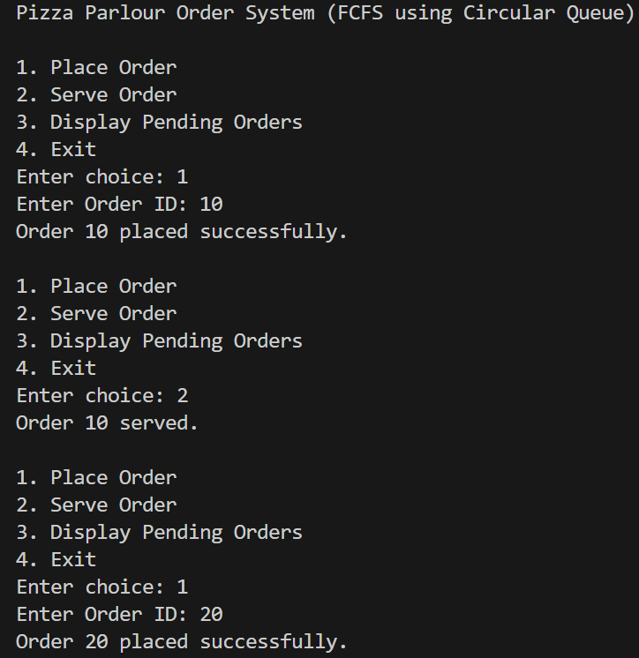
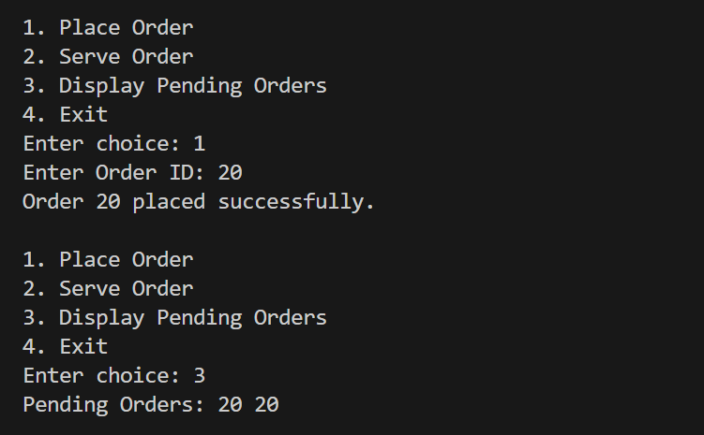

Problem 3 : Write a program that maintains a queue of passengers waiting to see a ticket agent. The program user should be able to insert a new passenger at the rear of the queue, Display the passenger at the front of the Queue, or remove the passenger at the front of the queue. The program will display the number of passengers left in the queue just before it terminates.
CODE:
#include <iostream>
#include <queue>
using namespace std;

int main() {
queue<string> passengers;
int choice;
string name;

while (true) {
cout << "\n--- Ticket Agent Queue System ---\n";
cout << "1. Add Passenger to Queue\n";
cout << "2. Display Passenger at Front\n";
cout << "3. Remove Passenger from Front\n";
cout << "4. Exit\n";
cout << "Enter your choice: ";
cin >> choice;

if (choice == 1) {
cout << "Enter passenger name: ";
cin >> name;
passengers.push(name);
cout << name << " added to the queue.\n";
}
else if (choice == 2) {
if (passengers.empty()) {
cout << "Queue is empty.\n";
} else {
cout << "Front Passenger: " << passengers.front() << endl;
}
}
else if (choice == 3) {
if (passengers.empty()) {
cout << "No passenger to remove.\n";
} else {
cout << "Removing: " << passengers.front() << endl;
passengers.pop();
}
}
else if (choice == 4) {
cout << "\nProgram terminating...\n";
cout << "Passengers left in queue: " << passengers.size() << endl;
break;
}
else {
cout << "Invalid choice!\n";
}
}

return 0;
}

OUTPUT:
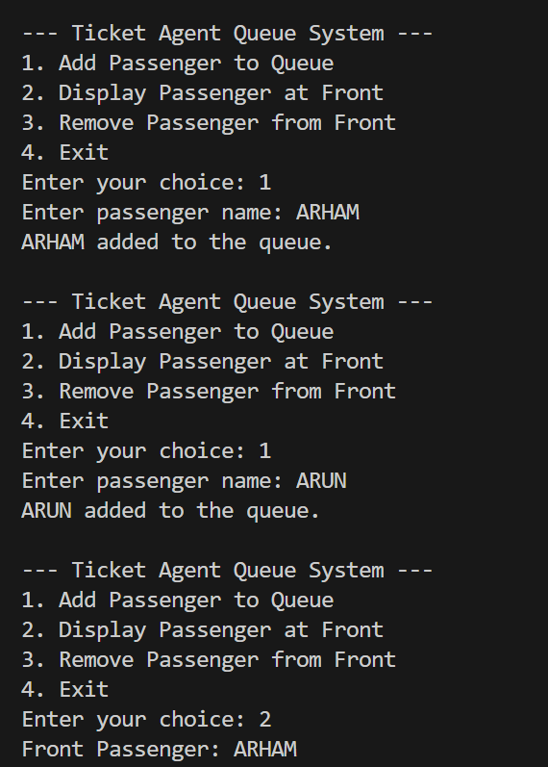
Problem 4 :
Write a program to implement multiple queues i.e. two queues using array and perform following operations on it. A. Add Queue, B. Delete from Queue, C. Display Queue
CODE:
#include <iostream>
using namespace std;

#define MAX 50

struct Queue {
int arr[MAX];
int front, rear;
};

void init(Queue &q) {
q.front = q.rear = -1;
}

bool isFull(Queue q) {
return q.rear == MAX - 1;
}

bool isEmpty(Queue q) {
return q.front == -1;
}

void enqueue(Queue &q, int value) {
if (isFull(q)) {
cout << "Queue Overflow!\n";
return;
}
if (isEmpty(q)) {
q.front = q.rear = 0;
} else {
q.rear++;
}
q.arr[q.rear] = value;
cout << "Inserted: " << value << endl;
}

void dequeue(Queue &q) {
if (isEmpty(q)) {
cout << "Queue Underflow!\n";
return;
}
cout << "Deleted: " << q.arr[q.front] << endl;
if (q.front == q.rear) {
q.front = q.rear = -1; // Empty queue
} else {
q.front++;
}
}

void display(Queue q) {
if (isEmpty(q)) {
cout << "Queue is empty\n";
return;
}
cout << "Queue elements: ";
for (int i = q.front; i <= q.rear; i++) {
cout << q.arr[i] << " ";
}
cout << endl;
}

int main() {
Queue q1, q2;
init(q1);
init(q2);

int qChoice, choice, value;

while (true) {
cout << "\n--- Select Queue ---\n";
cout << "1. Queue 1\n";
cout << "2. Queue 2\n";
cout << "3. Exit\n";
cin >> qChoice;

if (qChoice == 3)
break;

Queue *selected = (qChoice == 1) ? &q1 : &q2;

cout << "\n--- Operations ---\n";
cout << "1. Add\n";
cout << "2. Delete\n";
cout << "3. Display\n";
cout << "Enter choice: ";
cin >> choice;

switch (choice) {
case 1:
cout << "Enter value: ";
cin >> value;
enqueue(*selected, value);
break;
case 2:
dequeue(*selected);
break;
case 3:
display(*selected);
break;
default:
cout << "Invalid choice!\n";
}
}
return 0;
}

OUTPUT :
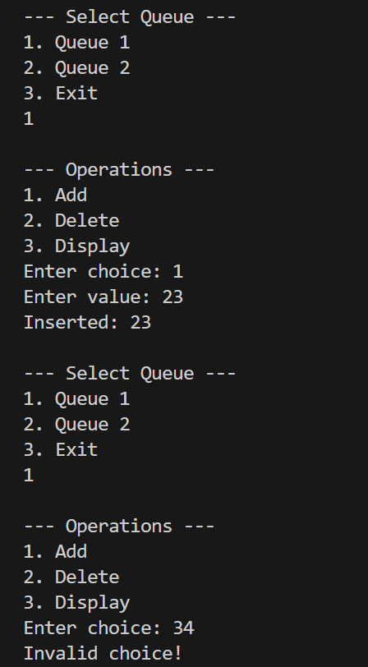
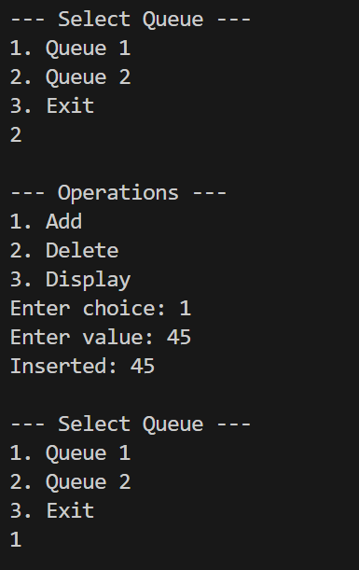
Problem 5 : In a call center, customer calls are handled on a first-come, first-served basis. Implement a queue system using Linked list where:
● Each customer call is enqueued as it arrives.
● Customer service agents dequeue calls to assist customers.
● If there are no calls, the system waits.

CODE:
#include <iostream>
using namespace std;

struct Node {
string customerName;
Node* next;
};

class CallQueue {
Node* front;
Node* rear;

public:
CallQueue() {
front = rear = NULL;
}

// Enqueue: Add new call
void enqueue(string name) {
Node* temp = new Node();
temp->customerName = name;
temp->next = NULL;

if (rear == NULL) {
front = rear = temp;
} else {
rear->next = temp;
rear = temp;
}
cout << "Call from " << name << " added to queue.\n";
}

// Dequeue: Remove call for service agent
void dequeue() {
if (front == NULL) {
cout << "No calls in queue. Agents waiting...\n";
return;
}

Node* temp = front;
cout << "Connecting call of: " << temp->customerName << endl;

front = front->next;
if (front == NULL)
rear = NULL;

delete temp;
}

// Display all waiting calls
void display() {
if (front == NULL) {
cout << "No calls waiting.\n";
return;
}

Node* temp = front;
cout << "Current waiting calls:\n";
while (temp != NULL) {
cout << " - " << temp->customerName << endl;
temp = temp->next;
}
}
};

int main() {
CallQueue cq;
int choice;
string name;

while (true) {
cout << "\n--- Call Center System ---\n";
cout << "1. New incoming call\n";
cout << "2. Agent takes next call\n";
cout << "3. Display waiting calls\n";
cout << "4. Exit\n";
cout << "Enter choice: ";
cin >> choice;

switch (choice) {
case 1:
cout << "Enter customer name: ";
cin >> name;
cq.enqueue(name);
break;

case 2:
cq.dequeue();
break;

case 3:
cq.display();
break;

case 4:
cout << "System closing...\n";
return 0;

default:
cout << "Invalid choice.\n";
}
}
}

OUTPUT :
